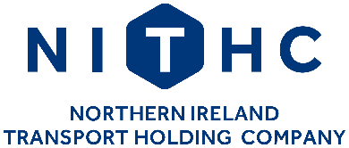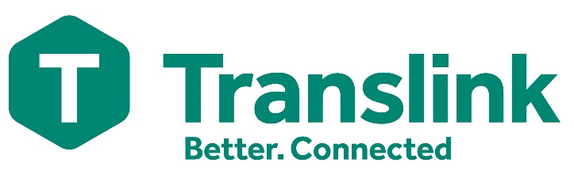

**Northern Ireland Transport Holding Company and Translink**

**EQUALITY IMPACT ASSESSMENTS AND SCREENING OUTCOME REPORT**

**January – March 2023**

22 Great Victoria Street

Belfast

BT2 7NJ

**Access to documents**

This publication is a summary of Equality Impact Assessments (EQIA) and screening reflective of the period January to March 2023 and summarises all the key findings and conclusions of each EQIA and the final decision of all screening. It can be made available in large-print, on disk, on audiocassette and in Braille and in other languages on request. For information about obtaining a copy in any of these formats – or to request a copy in any other accessible format – please contact:

Paula Logue

HR Manager

22 Great Victoria Street

Belfast

BT2 7NJ

Telephone 028 90899428

E mail Paula.Logue@Translink.co.uk

Textphone 028 90 66 66 30 (This connects to the Translink Call Centre)

This document and other documentation relating to the Equality Scheme can be accessed on the Translink website at www.translink.co.uk.

Various references to earlier reports may be made throughout this document. Each of the earlier reports is available upon request if not still accessible on the Translink website. Hard copies and copies in alternative formats can be made available on request.

**Section 75**

Under Section 75 of the Northern Ireland Act 1998, the Northern Ireland Transport Holding Company (NITHCo) is required **to have due regard to the need to promote equality of opportunity** –

* between persons of different;

o religious belief

o political opinion

o racial group

o age

o marital status

o sexual orientation

* between men and women generally;
* between persons with a disability and persons without; and
* between persons with dependants and persons without.

Without prejudice to the obligations set out above, NITHCo is also required **to have regard to the desirability of promoting good relations between persons of different religious beliefs, political opinion or racial group**.

Schedule 9 of the Act sets out the detailed procedure for the implementation of this duty including the publication of an Equality Scheme and the conduct of Equality Impact Assessments (EQIA) of selected policies. In response to the Act, NITHC has an active Equality Scheme approved by the Equality Commission. The Equality Scheme can be accessed on the Translink website at [www.translink.co.uk](http://www.translink.co.uk).

**NITHCo and Translink**

NITHCo is a public corporation established under the Transport Act (NI) 1967 to oversee the provision of public transport in Northern Ireland. It is responsible for the operation of its subsidiary companies, Citybus (which operates Metro bus services), NI Railways and Ulsterbus, which operate together under the brand name Translink to deliver scheduled bus and rail services in Northern Ireland, including cross-border and cross-channel links. NITHCo is accountable to the Department for Infrastructure (DFI) which develops transport strategies for Northern Ireland and determines public transport policy.

The NITHCo Board is responsible for approving the strategies of its subsidiary companies and the annual Corporate Plan and for their proper governance. It meets on a regular basis to review the implementation of policy objectives and to monitor financial performance. NITHCo also owns a portfolio of property investments that generate funds for capital investment throughout the Group.

The responsibilities of the various bodies which together deliver public transport services in Northern Ireland can best be illustrated as follows:

**Screening of policies**

The Equality Scheme includes a commitment to applying a systematic screening process. If the conclusion reached at the end of the screening process is that the policy has (or is likely to have) a significant impact on equality of opportunity, then consideration will be given to undertaking an Equality Impact Assessment (EQIA). This is a thorough review of a policy, including consultation with everyone affected by it, which can result in suggestions for change.

**Screening Outcome**

The screening outcomes are outlined in the table below. Three possible outcomes are recorded:

If Major – an Equality Impact Assessment may be carried out. EQIA - subject to further scrutiny under Section 75 of the NI Act 1998 to determine the impact upon those directly affected, which in turn will require informal and formal consultation with a wide range of stakeholders.

If Minor – consider mitigation or alternative policy and screen out.

If None – screen out and give reasons.

Screening Outcome Options

Major= In

Minor= Out with mitigation

None= Out without mitigation

# **Equality Screening Outcome report**

NITHCo and Translink undertook screening within the last quarter on the following policies:

|  |  |  |  |
| --- | --- | --- | --- |
| **Description of Policy / Proposal** | **Policy Information** | **Policy Status** | **Screening Decision** |
| Translink’s Future Ticketing Systems (TFTS) Project | An updated screening exercise to reflect the current status of Translink’s TFTS Project. | Revised | Screened out without mitigation |
| Dignity At Work Policy | Outlining the company’s views and expectations on applying equal rights and opportunities to all staff as well as defining bullying, harassment and victimisation. It also details the procedures should someone wish to report or complain about any incident(s) that breach the policy. | Existing | Screened out without mitigation |
| Lost Property Policy | Minor changes to the policy on dealing with unclaimed item(s) of lost property so that the items are properly accounted for, securely stored and appropriately disposed of. | Existing | Screened out without mitigation |